**Coupon Code** [**https://citria.org/admin/coupon-code**](https://citria.org/admin/coupon-code)

This is a React component to manage coupon codes in two different views:

1. Uses the useState hook to manage the active view state - either "list" to show existing coupons, or "create" to add a new coupon.
2. Renders a title, intro text and a toggle button group to switch between views:
   * CouponCodeList - To display list of all coupon codes
   * CreateCouponCode - To create a new coupon code
3. Conditionally shows one of the two components based on the state value.
4. Passes the state setter function as a prop to the CreateCouponCode component so that it can change the state back to "list" after creating a coupon.

In summary, this CouponCode component handles the state management and reuse of the sub-components for listing and creating coupons. Keeping them modular with the shared state allows more code reuse and separation of concerns.

**Coupon Code List**

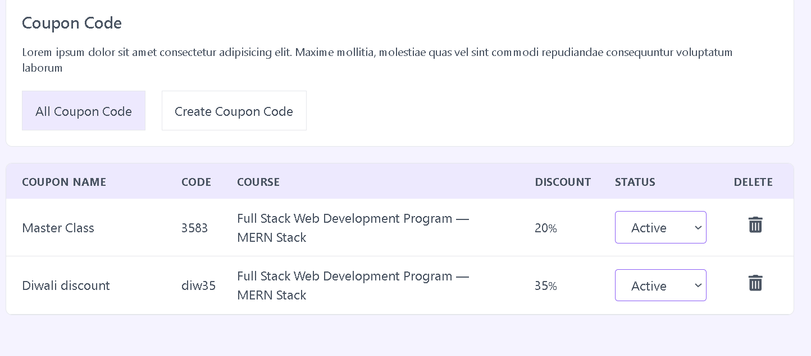

This is a React component to display a list of coupon codes and allow managing them. Here are the key things it does:

1. Uses a custom hook useGetAllCouponCode to fetch the coupon codes data and loading state.
2. Renders a table with columns for all the coupon details like name, code, course, discount etc.
3. Displays a loading skeleton while fetching data.
4. Maps through and displays each coupon code in a separate row.
5. Allows changing coupon status between pending/active/inactive.
6. Makes API call to update status on change, handles errors and notifications.
7. Shows a delete confirmation modal before deleting a coupon.
8. Handles coupon delete API call and notifications.
9. Displays error messages if data fails to load.
10. Handles auth errors globally to redirect to login.

So in summary, it is a reusable table component to display and manage coupons in one place using multiple custom hooks and state variables to handle various actions.

**Create Coupon**

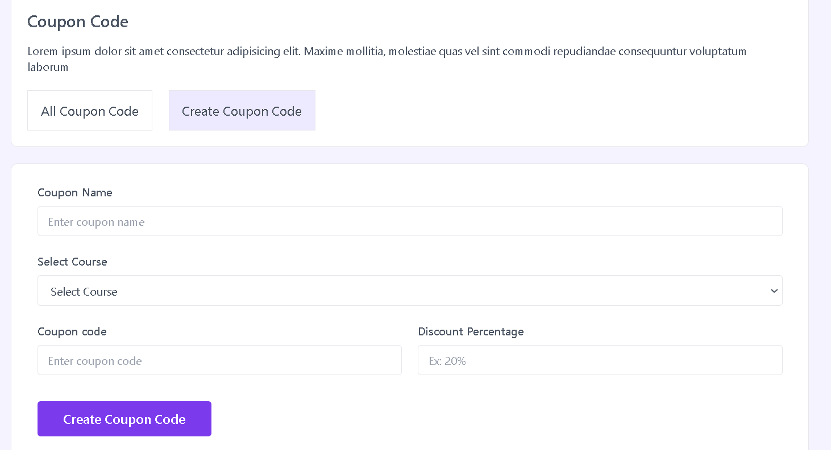

This is a React component for admin users to create a new coupon code. Here are the key things it does:

1. Uses state, context API and custom hooks to handle form data, errors, submissions, loading state and notifications.
2. Fetches list of courses using a hook to display in dropdown.
3. Renders input fields for:
   * Coupon name
   * Select course
   * Coupon code
   * Discount percentage
4. Validates form data on submit and shows any errors.
5. On successful submission, makes API call to create the coupon code.
6. Handles loading state and error handling for API call.
7. Shows toast notifications based on API response.
8. Passes state setter function to parent to switch back to coupons list view.
9. Has proper input handling and state lifting.

So in summary, this is a reusable coupon creation form that handles all the data and interactions needed to add a new coupon code. It can be reused across the application easily.